

CSE461
Introduction to Robotics Lab

Lab No. : 02
Group : 01
Section : 06
Semester : SUMMER_2025

Group members :
B M RAUF | 22201782
AZMARI SULTANA | 22201949
SAYEBA NASIR | 22201354

Submitted Date: 11-07-2025
Submitted to - CSDM

- Objectives:
The objective of this lab is to introduce the basics of a microcontroller using Raspberry PI. It includes understanding the pins of the board, their functions and how to use the GPIO – General Purpose Input Output pins to interact with simple I/O devices. It also focuses on learning the working principles of ultrasonic sensors and how they can be used to measure distance. Finally, it involves controlling an LED using Raspberry PI based on the distance measured by the ultrasonic sensors.

- Equipments:
● Raspberry PI development board
● LED (Light Emitting Diode)
● Ultrasonic Sensor(HC-SR04)
● Resistor (appropriate value for current limiting, typically around 220 ohms)
● Jumper wires
● Breadboard
● USB pen drive containing OS

- Experimental Setup:
Experiment 01 : LED Blinking
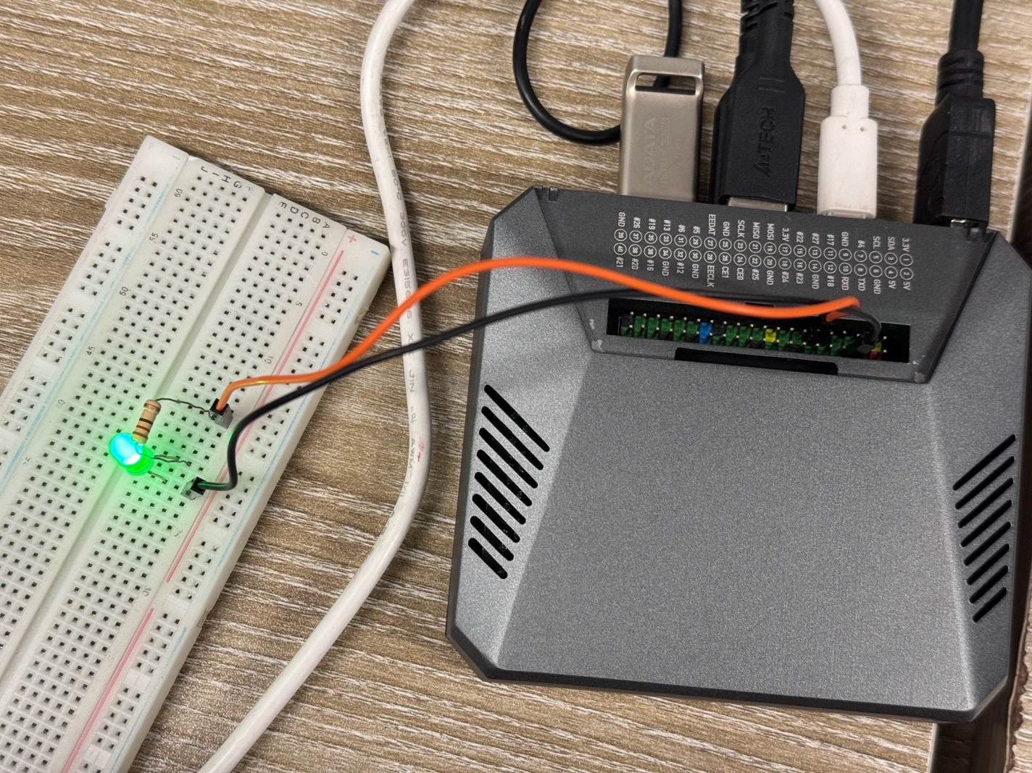
In this experiment, we connected one end of a 220-ohm resistor to a GPIO pin of the Raspberry Pi and the other end to the anode of the LED. Then, we connected the cathode of the LED to a ground pin on the board. We used GPIO pin 17 to send signals to the LED, and using a Python program, we controlled the LED to turn ON and OFF repeatedly with a 1-second delay.

Experiment 02 : Measuring distance using ultrasonic sensor
In this experiment, we used an HC-SR04 ultrasonic sensor to measure the distance between the sensor and an object. The sensor was connected to the Raspberry PI: the VCC pin to 5V, GND to ground, TRIG to GPIO pin 21, and ECHO to GPIO pin 20. Since the ECHO pin outputs 5V, which can damage the Raspberry PI's 3.3V GPIO pins, a voltage divider circuit using resistors was used to safely reduce the voltage. Using a Python program, we send a short trigger pulse from the Raspberry PI to the sensor. The sensor then sent out ultrasonic waves and waited for them to bounce back. By measuring the time, it took for the echo to return, the program calculated the distance(cm).

Lab Task : Turn an LED on if the distance measured by the ultrasonic sensor is less than 5CM
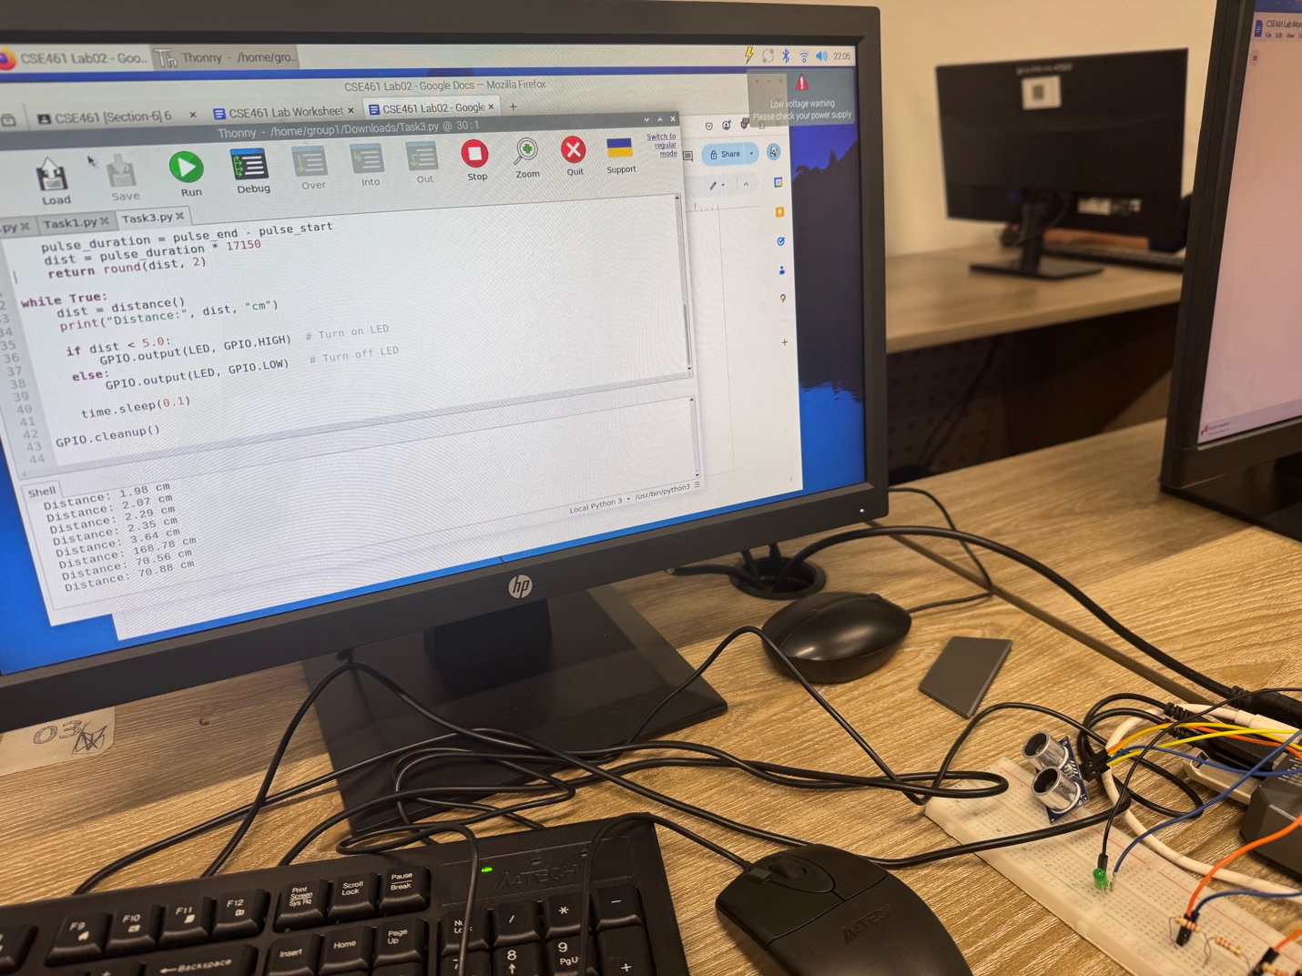
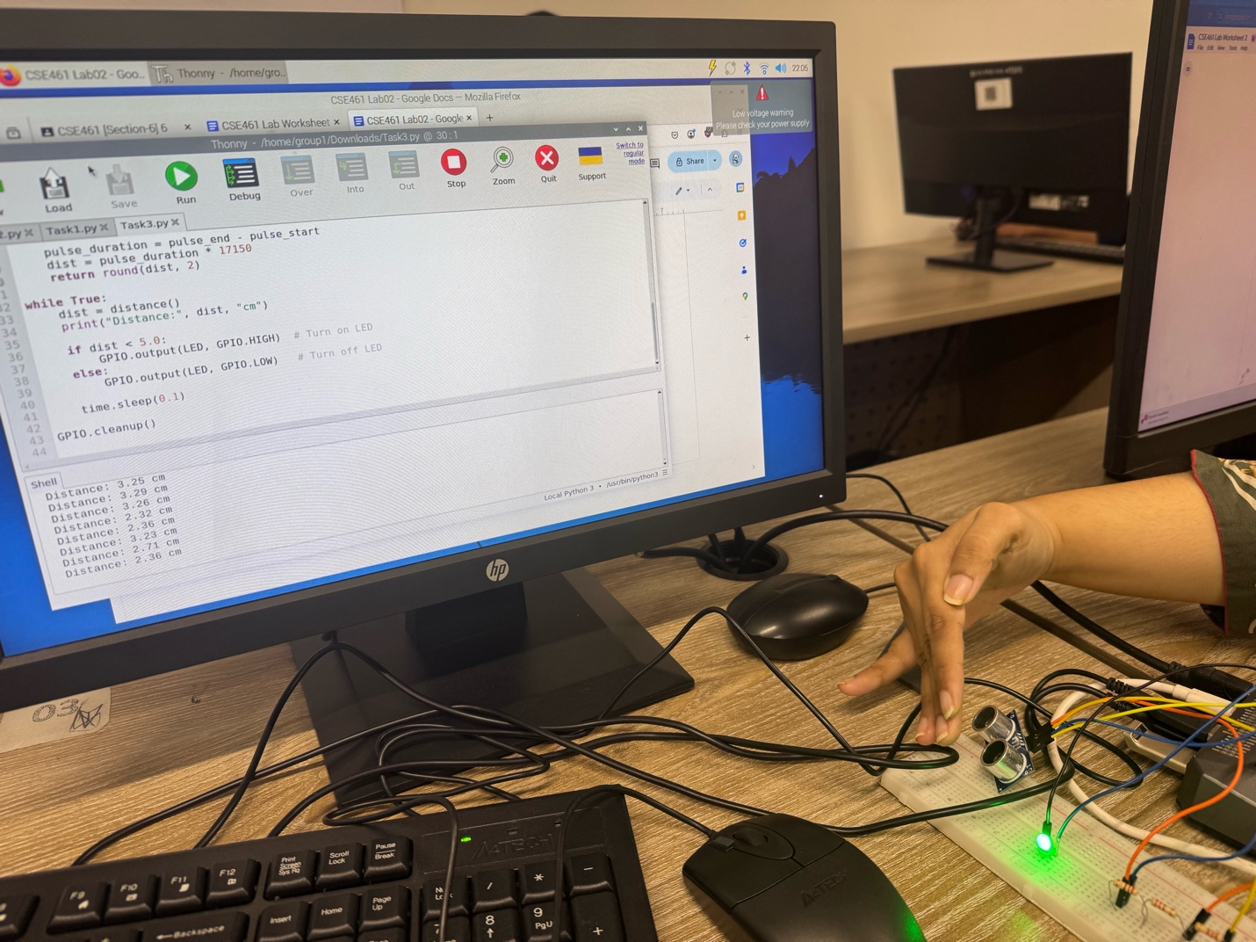
In this task, we combined the use of the ultrasonic sensor and an LED to build a simple distance-based alert system. We connected HC-SR04 ultrasonic sensor to the Raspberry PI with GPIO pin 21 for the TRIG signal and GPIO pin 20 for the ECHO signal. The LED is connected to GPIO pin 17. Same voltage divider circuit from experiment 02 is also used here. We used a Python program to continuously measure the distance(cm) between the sensor and an object. If the measured distance is less than 5 centimeters, the program turns the LED on by sending a HIGH signal to GPIO pin 17. If the distance is 5 cm or more, the LED is turned off. It demonstrates how sensor data can be used to control output devices through GPIO pins in real-time.

- Code:
import RPi.GPIO as GPIO
import time

# GPIO pin setup
GPIO.setmode(GPIO.BCM)
TRIG = 21 # GPIO21
ECHO = 20 # GPIO20
LED = 17 # GPIO17 for LED

GPIO.setup(TRIG, GPIO.OUT)
GPIO.setup(ECHO, GPIO.IN)
GPIO.setup(LED, GPIO.OUT)

def distance():
GPIO.output(TRIG, False)
time.sleep(0.05)

GPIO.output(TRIG, True)
time.sleep(0.00001)
GPIO.output(TRIG, False)

while GPIO.input(ECHO) == 0:
pulse_start = time.time()

while GPIO.input(ECHO) == 1:
pulse_end = time.time()

pulse_duration = pulse_end - pulse_start
dist = pulse_duration * 17150
return round(dist, 2)

while True:
dist = distance()
print("Distance:", dist, "cm")

if dist < 5.0:
GPIO.output(LED, GPIO.HIGH) # Turn on LED
else:
GPIO.output(LED, GPIO.LOW) # Turn off LED

time.sleep(0.1)

GPIO.cleanup()

- Results (Output of the experiment):
If distance between the sensor and the object < 5.0:
Output = high, LED ON
Else:
Output = low, LED OFF

- Discussions/Answers:
From this lab, we learned how to interact with simple I/O devices specifically an LED and an ultrasonic sensor using a Raspberry PI microcontroller.

In Experiment 01, we encountered an issue where we were trying to make an LED blink. Initially, we connected the LED to GPIO pin 4 as shown in the worksheet, but it didn’t turn on. After checking the circuit multiple times, we suspected that there might be an issue with that specific GPIO pin. We switched to GPIO pin 17, and the LED blinked as expected.

In Experiment 02, while trying to measure distance using the ultrasonic sensor, the readings weren’t coming through. We checked the wiring and code but couldn’t find any mistakes. We guessed the problem might be with the connections or the echo signal not returning properly. So, we disconnected everything and reconnected the components from scratch, following the circuit diagram carefully. This time, the sensor started working and began printing distance values to the terminal.

Overall, the lab helped us understand the fundamentals of microcontroller, GPIO pin usage, how ultrasonic sensor could use to measure distance. It also showed us the practical side of troubleshooting, where even small connection errors or pin issues can cause an experiment to fail.

